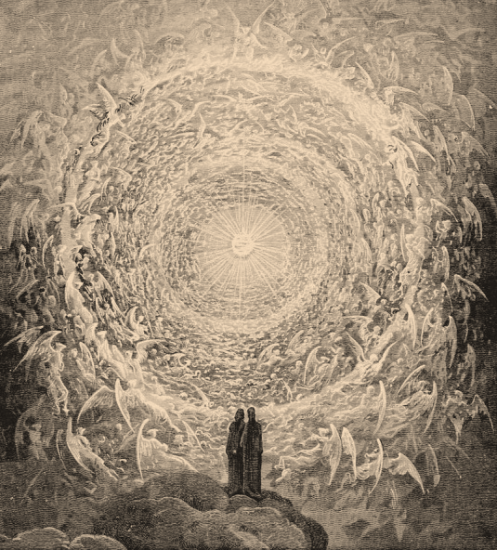
FBC Family Bible Class
October 2018
8:30 AM

Class Subject: Angelology 401: The Study of Angelic Beings, Satan and Demons.

Lesson: #2: A discussion on the names and character of angelic beings as well as their attributes and works.

Names matter. Character matters. Names are quickly associated with the character of a person.

I. THE NAMES of ANGELS:
1. LUCIFER: “Light Bearer” from the Hebrew word, “Heblel” which means brilliant, magnificent, splendid. (Isaiah 14:12,14)
2. GABRIEL: “Man of God” means, strength: The messenger angel.
- Daniel: (Daniel 8:16; 9:21,26), Zacharius: (Luke 1:11,19), Mary: (Lk. 1:26,27), Joseph: (Mtt.1:20; 2:13,19), Jesus in the Garden of Gethsemane: (Luke 22:43), Apostles in Prison. (Acts 5:19), Philip: (Acts 8:26), Peter: (Acts 12:7), Herod: (Acts 12:23), Paul: (Acts 27:23), John: (Rev. 22:8)
3. MICHAEL: “Who is Like the LORD” - Most powerful angel: Related to Israel and the Resurrection. (Daniel 10:13; 12:1,2; I Thess. 4:19) Described as the Archangel in Jude 9. Appearances: (Daniel: Daniel 10:13,21; 12:10) – Satan on Earth: (Jude 9) – Satan in Heaven: (Rev. 12:7)
4. CHERUBIM: Literally means, “To till or plough.”
- Guardian of the Garden of Eden: Exodus 25:18-22
- Guardian of the Temple: I Kings 6:23-29
- Guardian of the Throne of God: (Four Living Creatures) – Rev. 4:6-8
5. SERAPHIM: Literally means, “Burners” – concerned with the holiness of God. (Isaiah 6:3) and the cleansing of man. (Isaiah 6:6,7)
- They Covered their faces, They Covered their feet, with two wings they did fly:
6. VARIOUS NAMES OR TITLES FOR ANGELS:
- Gods – (Psalm 97:7; Hebrews 2:7)
- Sons of God – (Job 38:7; Daniel 3:25)
- Sons of the Mighty – (Psa. 29:1; 89:6,7; Isa. 13:13; Joel 3:11)

- Watchers – (Dan. 4:13,14; Isa. 62:6)

- They watched the ____________________________: (I Cor. 4:9)

- They watch the ______________________________: (Eph. 3:10)

- They watch ________________________: (I Cor. 11:3,10)

- They watch the ______________________________: (I Tim. 5:17-20, 22-25)

- They watch our ______________________________: (Matt. 16:27)

- Holy Ones – (Zech. 14:5; Mtt. 25:31; Dan. 8:13)
- Princes – (Dan. 10:13, 20,21; 12:1)
- Thrones (Rulerships) – (Col. 1:16)
- Dominions (the Power to Rule) – (Col. 1:16)
- Powers (Authority) – (Col. 1:16)
- Principalities (Governments) – (Col. 1:16)
- Morning Stars – (Job 38:7; Rev. 22:)
- Beasts – (Rev. 4:6-8; Ezek. 1:6-11)
- Elect – (I Tim. 5:21)
II. The Character of Angels:
A. They are ___________________________. (Intellect, Emotion, Will) – (Ezek. 28:12; Mtt. 28:5; Rev. 17:1; Job 38:7; Luke 15:10; Isiah 6:2-3; Heb. 1:6)
B. They are ___________________________. (limited in time, space, matter)
III. Attributes of Angels: Powerful Beings.
A. Angels are Powerful Beings - Called “Mighty Ones” (2 Thess. 1:7) One angel killed 185,000 Assyrian Soldiers in one night. (Isaiah 37:36)
- The Power of Angels Comes from God. The angels are not __________________________________.
- The Strength of Angels Comes from God and must live in sync with God’s laws.
- The Intervention of Angels are either permitted or commanded by God.
B. Angels are Intelligent Beings, but they are not ___________________________________.
- Matthew 24:36
- Ephesians 3:10
- Romans 1:21
- I Peter 1:12
C. Angels are Innumerable Beings, but they are not _______________________________________.
D. Angels are Confirmed Beings in their ________________________________. There is no atonement for fallen angels (2 Peter 2:4; Jude 6)
IV. The Work of Angels:
A. The General Works of Angels:
- Before the ____________________ of Scripture they were messengers of the Word and Will of God. (Heb. 1:1; Rev. 22:8; Judges 13:3,9-21)

- They ____________________ captive men. (Acts 5:19; 12:7; Mtt. 26:53)

- They ____________________ godly men. (Elijah – I Kings 19:8; Jesus – Mtt. 4:11)

- They brought God’s _____________________________ to evil men. (2 Sam. 24:15-18; Acts 12:21-23; Mtt. 13:41,42)

- They _______________________________ dead saints to heaven. (2 Cor. 5:8; Luke 16:22)

- They _______________________________. (Lot and his family: Gen. 19:11-13; Daniel in the lion’s den: Dan. 6:22; King David: Psa. 34:7)

- They influence and __________________________________ us to live godly lives. (Gideon: Judges 16:12; The Paralyzed Man: Jn. 5:9)

- They lead us to ______________________________. (Acts10:3-5)

- They lead us into _____________________________. (Acts 5:5-6; 26-39)

- They bring to us ______________________________. (1 Chronicles 21:1; 2 Samuel 24:10,13-16)

- They ________________________________. (I kings 19:1-8)
B. The Specific Works of Angels:
- Angels and ___________________________: (Isaiah 6:1-7; Rev. 4:6-9)

- Angels and ____________________________:

- Predicted Christ’s Birth. – Lk. 1:30-33
- Announced Christ’s Birth. – Lk. 2:10-14
- Warned of Herod’s Plot. – Mtt. 2:19,20
- Ministry after the temptation in the wilderness. – Mtt. 4:11
- Ministry before the betrayal and crucifixion. – Lk. 22:43
- On call at the arrest of Christ. – Mtt. 26:53
- Rolled back the stone from the grave. – Mtt. 28:2
- First announcement after the resurrection. – Mtt. 28:6
- Ascension of Christ. – Acts 1:11
- Return of Christ. – Mtt. 25:31
- Judgment of Christ. – Mtt. 13:39,40
3. Angels and the ___________________________________:
- They may appear in our church services. (I Cor. 11:10; Ephesians 3:10; I Timothy 5:21)
- They guide, comfort and defend. (Acts 5:19; 12:7; 27:21-35
4. Angels and ______________________________________: (Rev. 7:1-3)
5. Angels as ________________________________________:
- Children: Matthew 18:10,11
- Acts 12:15
- John 10:27-30
6. Angels and the ____________________________________: (Daniel 12:1)
7. Angels and the _________________________:
- Acts 12:23
- Rev. 19:17 / Genesis 18:12,13
- Matthew 13:39,40
- Luke 15:10
8. Angels and the Second Coming of Christ:
- Luke 9:38
- Matthew 25:31-34
- Rev. 20:1-3
9. Angels and the _______________________________ State:
- I Cor. 5:24-28
- Rev. 21: 22:
- Col. 1:20
Some Things to Think About:
How has this lesson and these lessons on Angels changed your views on God and on the spiritual, heavenly realms all around us?

How will your faith and testimony change as a result of this study?

