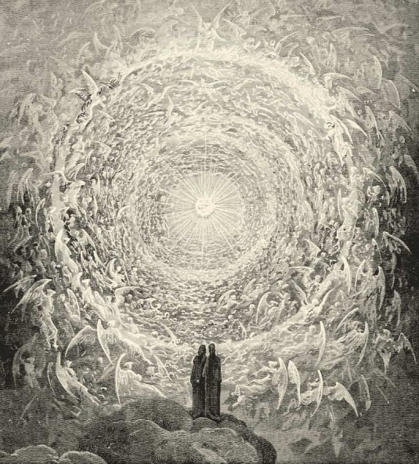
FBC Adult Sunday School Class
October 14th, 2018
8:30 AM

Class Subject: Angelology 401: The Study of Angelic Beings, Satan and Demons.

Lesson: #1: A General Overview of the Doctrine of Angelology, Satanology and Demonology and the serious misconceptions by the world, the church, and professing believers. We will examine our role in defeating
our one and only enemy Satan.

Working Lesson Outline:
1. What and Why is there such a Fascination Today with Angels? (Towns, p.313)
____________________________________________________________________________________________________________________________________________________________________________________________________
2. Why Study the Doctrine of Angels? How will it benefit our faith and faithfulness? (Towns, p.314; Grudem, p.401-407; Ryrie, p.121)
____________________________________________________________________________________________________________________________________________________________________________________________________
3. Description and Definitions of Angels: (Towns, p.313)
- Created Angelic Beings: (Grudem, p.397; Ryrie, p.124)
______________________________________________________________________________________________
- Sons of God: (Grudem, p.397)
______________________________________________________________________________________________
- Cherubim: (Chafer, p.17,18; Grudem, p.398)
______________________________________________________________________________________________
- Seraphim: (Chafer, p. 18)
______________________________________________________________________________________________
- Archangels: (Chafer, p.19,20)
______________________________________________________________________________________________

- Michael – (Grudem, p.398)
______________________________________________________________________________________________
- Lucifer / Satan –
______________________________________________________________________________________________
- Gabriel – (Grudem, p. 399)
______________________________________________________________________________________________
- Ministering Spirits:
______________________________________________________________________________________________
- Elect Angels: (Chafer, p.17)
______________________________________________________________________________________________
- Living Creatures: (Grudem, p.398)
______________________________________________________________________________________________
- Guardian Angels: (Swindoll, p.630; Grudem, p.399)
______________________________________________________________________________________________
- Fallen Angels:
______________________________________________________________________________________________
- Demons:
______________________________________________________________________________________________
- Nephilim:
______________________________________________________________________________________________
4. Definition of the Word, “ANGEL:” (Chafer, p.3; Towns, p.313)
____________________________________________________________________________________________________________________________________________________________________________________________________
5. For What Ministry Were Angels Created? (Towns, p.313; Chafer, p.11, 21-24; Swindoll, p.626; )
____________________________________________________________________________________________________________________________________________________________________________________________________

6. What is the Biblical Support for Angels, Satan and Demons? (Chafer, p.3,4)
____________________________________________________________________________________________________________________________________________________________________________________________________
7. Where Do Angels Live? (Chafer, p. 6,7, 14,15; Swindoll, p.633)
____________________________________________________________________________________________________________________________________________________________________________________________________
8. What Kind of Power and Organization Do Angels Possess? (Chafer, p.16,17; Grudem, p.400; Ryrie, p.128)
____________________________________________________________________________________________________________________________________________________________________________________________________
9. Why Are We Unable to See Angels? (Chafer, p.8)
____________________________________________________________________________________________________________________________________________________________________________________________________
10. Do Angels Have Physical Bodies? (Chafer, p. 9,12)
____________________________________________________________________________________________________________________________________________________________________________________________________
11. What are the Personalities of Angels? (Chafer, p.10,11; )
____________________________________________________________________________________________________________________________________________________________________________________________________
12. Do Angels Have Wings? (Chafer, p.13; Swindoll, p.630)
____________________________________________________________________________________________________________________________________________________________________________________________________
13. Do Angels Watch Us? Why? (Chafer, p.26; Grudem, p. 397)
____________________________________________________________________________________________________________________________________________________________________________________________________
14. Should we Pray or Worship Angels? (Swindoll, p.628)
____________________________________________________________________________________________________________________________________________________________________________________________________
15. Do Saved People Who Go to Heaven Become Angels? (Swindoll, p.629)
____________________________________________________________________________________________________________________________________________________________________________________________________
16. Do Angels Age and Die Like Humans? (Swindoll, p.629)
____________________________________________________________________________________________________________________________________________________________________________________________________
17. How Many Angels Are There? (Grudem, p.399)
____________________________________________________________________________________________________________________________________________________________________________________________________

