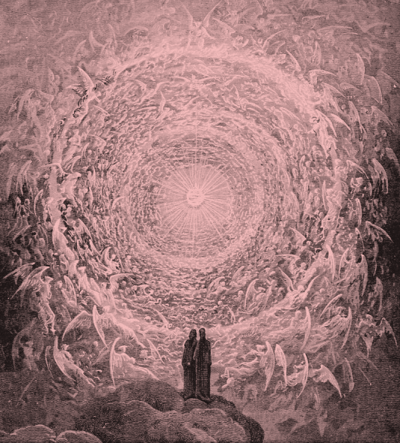
FBC Adult Sunday School Class
November - 2018
8:30 AM

Class Subject: Angelology 401: The Study of Angelic Beings, Satan and Demons.

Lesson: #6: A THEOLOGICAL AND BIBLICAL discussion on the Doctrine of Satan. We will discuss Satan’s origin, fall, the problem of evil, the personality, power, CHARACTER, NAMES and TITLES of Satan, his primary work and objectives, his methods and judgment and how we as believers can overcome him in and through our temptations.

Working Lesson Outline:
I. THE REALITY OF SATAN:
II. THE ORIGIN AND FALL OF SATAN:
III. THE PROBLEM OF EVIL:
IV. THE PERSONALITY OF SATAN:
V. THE POWER OF SATAN:
VI. THE CHARACTER OF SATAN:
VII. THE NAMES AND TITLES OF SATAN:
VIII. THE PRIMARY WORK AND OBJECTIVES OF SATAN:
IX. THE METHODS OF SATAN:
X. THE JUDGMENT OF SATAN:
XI. OVERCOMING SATAN AND TEMPTATION:

VI. The Character and Evil Nature of Satan: / VII. The Names and Titles of Satan:
1. What are the three ways the Word of God reveals t character of Satan?
1.) ____________________ 2.) ____________________ 3.) ____________________
2. Why is the word, “subtle” such an excellent descriptive word for Satan?
- 2 Corinthians 2:11
- 2 Corinthians 11:14
- Ephesians 6:11
3. Why do you think Satan is so subtle, crafty, Wiley, intelligent?
4. Why is Satan so filled with evil? I John 3:8; 5:18
5. What purpose does a name serve?
6. The Names and Titles of Satan:
1.) Satan – Job 1:6
2.) Devil – Revelation 12:7
3.) ___________________________________. – Matthew 12:27
4.) Belial – 2 Corinthians 6:15
5.) Old Serpent – Revelation 20:2
6.) Apollyon - Revelation 9:11
7.) Adversary – 1 Peter 5:8
8.) Anointed Cherub – Ezekiel 28:
9.) Deceiver of the whole world – Rev. 12:9
10.) Evil one – John 17:15
11.) Leviathan – Isaiah 27:1
12.) ___________________________________. – Isaiah 14:12
13.) Murderer – John 8:44
14.) Roaring Lion – I Peter 5:8
15.) Son of the Morning – Isaiah 14:12
16.) Wicked one – John 3:12
17.) Prince of the power of the air – Ephesians 2:2
18.) Prince of this world – John 14:30
19.) God of this age – 2 Cr. 4:4
20.) Dragon – Revelation 12:9
21.) Beast out of the bottomless pit – Rev. 11:7
22.) ____________________________________. – Rev. 12:10
23.) Angel of the bottomless pit – Matthew 4:1
24.) ____________________________________. – Matthew 4:1
25.) ____________________________________. – Matthew 13:39
26.) ____________________________________. – John 8:44
27.) Liar – John 8:44
28.) Prince of demons – Matthew 9:34
29) Man of sin – 2 Thessalonians 2:3
30.) Thief – John 10:10

VIII. The Primary Work and Objectives of Satan:
1. What is the threefold work of Satan? (p.355)
1.) ____________________ 2.) ____________________ 3.) ___________________
2. How has Satan opposed God down through time? (2 Timothy 3:1-9)
- He repudiated God in the ______________________________. Isaiah 14:12-14

- He drew a third part of the stars of heaven after him. Revelation 12:4

- He __________________________ from the beginning. I John 3:8

- He is a _______________________ from the beginning. John 8:44

- In the Garden of Eden he belittled God and advised the first parents to repudiate God. Genesis 3:1-5
- He insinuated to Jehovah that Job loved and served Him only as he was hired to do so. Job 1:9

- When permitted to act his own part, Satan brought five terrible calamities on Job. Job 1:13-2:7

- He stood up against Israel. I Chronicles 21:2; Psalm 109:6; Zechariah 3:1-2

- He ___________________________ the nations. Isaiah 14:16

- He made the earth to tremble. Isaiah 14:16

- He did shake kings and kingdoms. Isaiah 14:16

- H makes the world a wilderness. Isaiah 14:17

- He _____________________________ cities. Isaiah 14:17

- He opened not the house of his prisoners. Isaiah 14:17

- He causes __________________ on the earth with all its horrors. Revelation 20:2,7,8

- He ____________________________ Christ for 40 days and 40 nights proposing to Christ for Him to forsake His mission and to mistrust His Father’s goodness, and then to worship him. Luke 4:1-13

- He bound a daughter of Abraham from her illness for eighteen years. Luke 13:11-16; Acts 10:38

- He entered Judas and prompted him to betray the Son of Man. John 13:2

- He __________________________ the minds of those who are lost. 2 Corinthians 4:3,4

- He __________________________ the Word of God from the ears and hearts of hearers of truth. Luke 8:12
- He deals with the saints with wiles and snares. Ephesians 6:11; 2 Timothy 2:16

- He exercises and abuses the power of _____________________. Hebrews 2:14; Revelation 1:18

- As an _________________________ he goes around as a roaring lion seeking whom he may devour (drink down). I Peter 5:8

- He is the ________________________ of saints and of the church of Jesus Christ. John 8:44
3. Contrasting the Spirit of the Holy Spirit with the Spirit of Satan: (p. 357)
- The Dove. ________________________________

- The Spirit of Truth ________________________________

- The Gift of Tongues ________________________________

- The Life-Giving Spirit ________________________________

- The Helper ________________________________

- Our Advocate ________________________________

- The Master’s Winnowing ________________________________

- Builder of the Kingdom ________________________________

- Sovereign God ________________________________

- The Holy One ________________________________
IX. THE METHODS OF SATAN: (p. 363,364)
1. Matthew 13:4,19 He ______________________________ the good seed of the Word.
2. Luke 11:21 He _________________________ the unbeliever into a false sense of peace.
3. I Timothy 2:25,26 He lays ___________________________ for the unwary.
4. 2 Corinthians 11:13,14 He masquerades as an _____________________________________.
5. Revelation 12:9; I Timothy 2:14 He deceives the minds of those minds not subjected or cleansed by Christ and His Word.

6. Matthew 13:15,28 He perverts and mixes ____________________ with error.

X. THE JUDGMENT OF SATAN: (p. 353-355)
Chronology of Satan’s Judgment: (see Chart from the Greatest Book on Dispensational Truth by Clarence Larkin, c. 1918, pages: 112,113)
1. The Record of Satan’s Fall: Ezekiel 28: Isaiah 14:12-17; Luke 10:18

2. The Indictment Record of Satan: Genesis 3: Curse Upon Satan.

3. The Judgment Penalty of Satan Displayed: Hebrews 2:14,15

4. The Confinement of Satan to the Earth: Revelation 12:5-12

5. The Confinement of Satan During the Tribulation: Revelation 20:1-3

6. The Execution of Judgment Upon Satan: Revelation 20:9-11

