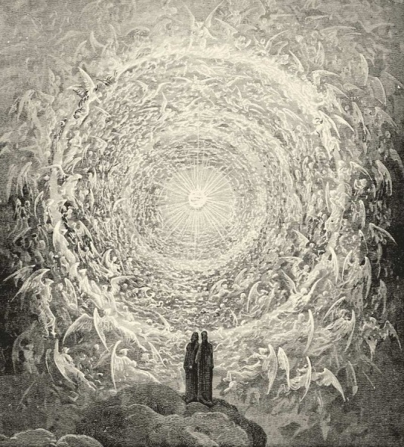
FBC Family Bible Hour
November - 2018
8:30 AM

Class Subject: Angelology 401: The Study of Angelic Beings, Satan and Demons.

Lesson: #7: A THEOLOGICAL AND BIBLICAL discussion on the Doctrine of Satan. We will discuss Satan’s origin, fall, the problem of evil, the personality, power, character, names and titles of Satan, his primary work, objectives, methods and judgment and how we as believers can overcome him in and through our temptations.

Working Lesson Outline:
I. THE REALITY OF SATAN:
II. THE ORIGIN AND FALL OF SATAN:
III. THE PROBLEM OF EVIL:
IV. THE PERSONALITY OF SATAN:
V. THE POWER OF SATAN:
VI. THE CHARACTER OF SATAN:
VII. THE NAMES AND TITLES OF SATAN:
VIII. THE PRIMARY WORK / OBJECTIVES OF SATAN:
IX. THE METHODS OF SATAN:
X. THE JUDGMENT OF SATAN:
XI. OVERCOMING SATAN AND TEMPTATION:

XI. Overcoming Satan and Temptation: (p.365-368) Towns: Systematic Theology
1. The Principle of Proper Respect:
- God will not allow us to be _____________________ beyond our ability to overcome it. (I Corinthians 10:13)

- We need to respect the _____________________ of God over Satan. (I John 4:4)

- We need to respect our enemy by not becoming ____________________________ in our flesh. (Jude 9)
2. The Principle of Proper Removal:
- The Leaven Principle: It was ____________________________ in the Passover. (Exo 12:8-20)

It was figurative of false ___________________________. (Matthew 16:6,12)

It was descriptive of infectious _________________________. (I Corinthians 5:5-7)

It is likened to false ___________________________. (Galatians 5:1-9)

We are to __________________________ from all appearance of __________________ (I Thessalonians 5:22; Genesis 39:12; Titus 3:10)

3. The Principle of Proper Resistance:

- Resist the ________________________. (James 4:7; I Peter 5:9)

- Know the ________________________ and be ready to use it as a _______________________. (Matthew 4:1-11; Ephesians 6:17; Hebrews 4:12)

4. The Principle of Proper Readiness:

- We are to be prepared by _________________________ and ___________________________. (Mark 14:38; Ephesians 6:11)

- We need to ________________________________ the Word when temptation comes. (Psalm 119:1,11)

5. The Principle of a Proper Mindset: (See 2 Corinthians 10:9,10)

- Our first order of business when seeking to do battle with Satan is to know who and what we are up against. “For the weapons of our warfare are not _________________________...”

- The work of God is “________________________.”

- “Strongholds, (fortresses)” are built in the mind one ___________________ or thought at a time.

- Satan’s objective to build a fortress of defiance against God in the mind begins in our “____________________________________.”

- The “High Thing” that exalts itself against the knowledge of God is anything that seeks to ___________________ the will, the work and the way of God.
6. The Principle of Using and Maintaining the Proper Equipment: (See Ephesians 6:10-18)
- God hasn’t asked us to fight this fight ___________________________. (Eph. 6:10)
- God expects for us corporately and individually to ______________________________ we have already won the battle. It is a battle for the mind.
- The battle with the world, the flesh and the Devil is not in our own ______________________ and power but God’s!

- We are expected to stand ____________________________ not alone. (Eph. 6:11)

- We must understand and study the ________________________ and schemes of the Devil. (Eph. 6:11)

- We fight on another ____________________ _______________________. With different rules of engagement. (Eph. 6:12)

- This fight is a fight to the __________________________.

- We fight standing up and standing for _________________________________. (Eph. 6:13)

- We must put on the Belt of ____________________________. (Eph. 6:14)

- We must put on the Breastplate of ____________________________________.

- We must put on the _______________________ of the Gospel of Peace. (Eph. 6:15)

- We must put on the Shield of _____________________________. (Eph. 6:16)

- We must put on the Helmet of ____________________________. (Eph. 6:17)

- We must practice with the Sword of the ____________________________, using it when attacked by the enemy. (Eph. 6:17)

- We must _______________________ always. (Eph. 6:18)

- We must _______________________ always, not just for ourselves but for our brothers and sisters in Christ who stand with us and for us on the battlefield of life. (Eph. 6:18)

- We must be ________________________ and _______________________________ because our adversary is walking around seeking whom he may devour. (I Peter 5:8)

Adult Sunday School Class Quiz
on the Doctrine of Angels and Satanology

1. Matching:

_____ Sons of God 1. Messengers: (angelos)

_____ Beelzebub 2. The Mighty One

_____ Cherubim 3. Guardians around the throne of God.

_____ Seraphim 4. Angels

_____ Archangels 5. Lord of the flies

_____ Lucifer 6. Fell from heaven as the Light Bearer

_____ Michael 7. Protector of Israel / Who is like God

_____ Gabriel 8. Guardians of God’s Holiness: Burners

_____ Nephilim 9. Defenders of God’s Holiness: To till or to plough

_____ Angel 10. Disembodied evil spirits

2. True or False:

- True or False? Two thirds of the angelic hosts of heaven fell following Lucifer in rebellion against God.
- True or False? Mankind is created a little higher than the angels.
- True or False? When we die our spirits become angels.
- True or False? Angels watch us so they can learn how to overcome Satan.
- True or False? We should worship and pray to angels.
- True or False? Angels know all things because they know God.
- True or False? The angels of God, in heaven, can still sin and rebel against God.
- True or False? Angels are sent by God often because of the prayers of God’s people.
- True or False? God can’t prevent evil, He is doing the best that He can.
- True or False? Satan wanted to destroy the line of Adam by corrupting it in order that the Messiah could not and would not come.

3. Satan’s Ultimate Judgment will be ______________________________________________________. Where is it found? ____________________________________.

