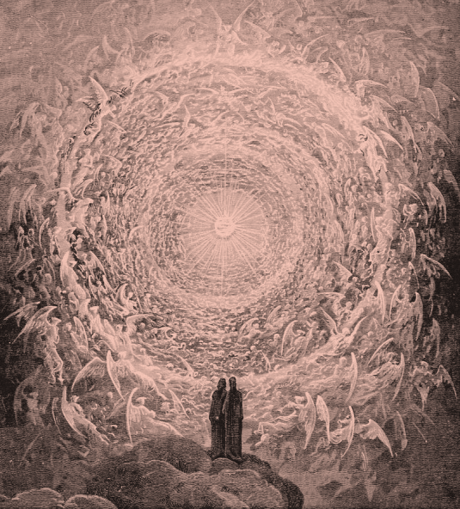
FBC Family Bible Class
November 2018
8:30 AM

Class Subject: Angelology 401: The Study of Angelic Beings, Satan and Demons.

Lesson: #4: A THEOLOGICAL AND BIBLICAL discussion on the Doctrine of Satan. We will discuss Satan’s origin, fall, the problem of evil, the personality, power, character, names and titles of Satan, his primary work and objectives, his methods and judgment and how we as believers can overcome him in and through our temptations.

Working Lesson Four Outline:
I. THE REALITY OF SATAN:
II. THE ORIGIN AND FALL OF SATAN:
III. THE PROBLEM OF EVIL:
IV. THE PERSONALITY OF SATAN:
V. THE POWER OF SATAN:
VI. THE CHARACTER OF SATAN:
VII. THE NAMES AND TITLES OF SATAN:
VIII. THE PRIMARY WORK AND OBJECTIVES OF SATAN:
IX. THE METHODS OF SATAN:
X. THE JUDGMENT OF SATAN:
XI. OVERCOMING SATAN AND TEMPTATION:

I. THE REALITY OF SATAN:
- In your opinion why is there such variant opinions on the subject of Satan?
- Where do people go to get their information on the subject of Satan? Where should we go?
- One of Satan’s names is: “Deceiver” what does this name tell us when seeking to understand the person, nature and work of Satan?
- When looking at another name of Satan: “Devil” what is the word within the name that best characterizes the person, nature and work of Satan?
II. THE ORIGIN AND FALL OF SATAN:
1. His heart was lifted up in ______________________________. (Isaiah 14:12-20)
2. What was Satan’s _____________________________ in his five “I WILL’S” in (Isaiah 14:12-15)?:
- “I will ascend into ____________________________.” – (verse 13a compare with Acts 1:9-11; Philippians 2:9-11; II Corinthians 12:1-10)
- “I will exalt my ________________________ above the stars of God.” – (verse 13b; *Ezekiel 28:5,16,18)
- “I will also sit on the _______________________ of the congregation on the farthest sides of the north.” – (verse 13c; See Isaiah 2:1-4; Psalm 48:2; 75:6,7)
- “I will ascend above the heights of the ____________________________.” – 100 of the 150 times the word “Cloud” is used it is used of God’s divine glory. (verse 14a; See Exodus 16:10; 40:38; I Kings 8:10; Psalm 104:3; I Thessalonians 4:17; II Thessalonians 2:4)
- “I will be ______________________ the Most High.” – (verse 14b; EL ELYON: Matthew 28:18)
3. He was perfect until __________________ was found in him. (Ezekiel 28:4-19) – What motivated Satan? (I Timothy 3:6)
4. He is the ______________________________ of all the fallen angels. (Revelation 12:7-9)
5. He is a __________________________ and the father of lies. (John 8:44)
III. THE ORIGIN OF EVIL:
- If God is a benevolent God, and able to exercise complete authority and power over His creation, where did Satan’s evil come from and why would God allow evil to enter His creation and ultimately, the world without stopping it? (See James 1:13)

- Why was it necessary for God to create within His creation of angels and human beings the agency of free will?

- Within the fallen heart of man is the insidious need to ask the question “WHY?” What should our question be? How was the “WHY?” present in the heart and mind of Satan?

- What does the term, “Theodicy” mean? (Theos: ______________; Dike: ___________________) The Problem of Evil: If God is good then He would want to eliminate evil. If God is omnipotent certainly God would want to prevent evil. Therefore some might conclude that either God is not good or He is not omnipotent.

- Some faulty Theodicies: (Identify the problems with these views)

- God can’t prevent ___________________. According to this view God is doing e best that He can to make the world a pleasant place, but don’t expect more than He is able to accomplish.
- God won’t prevent __________________. According to this view God is not a good God otherwise He would prevent evil. They point to the many references where God commanded Israel to slaughter innocent men, women and children.

- Evil is not _______________________. According to this view evil, like sin, sickness and death are illusory. Christian Science would teach this.

- What is a Christian Theodicy in relationship to the problem of evil?

- What was God’s original _________________ for His creation before sin entered the world? (Gen. 1:10,18,21,25,31)

- What ___________________________ God’s goodness towards man to continue? (Genesis 3: Romans 5:12)

- What was and continues to be God’s __________________ to reverse the curse on man and even upon this planet? Redemption. (Genesis 3:15; Romans 5:8; II Corinthians 5:17-21; Revelation 22:3)

- What are some difficult Scriptures dealing with this subject on the problem of evil?

- I Samuel 16:14; 18:10; 19:9; Judges 9:23 – compare with I Corinthians 5:5

- I Kings 21:21 compare with Proverbs 3:11,12; Hebrews 12:5-11

- Proverbs 16:4 compare with Ecclesiastes 7:29

- Ecclesiastes 3:1-8 compare with Ephesians 1:11

- Ecclesiastes 7:14

- Amos 3:6 see II Kings 17:7-17

- Isaiah 45:7 see Isaiah 45:1,2

- What then is God’s ___________________________ and intent for evil? (Genesis 50:20; Proverbs 16:4; Psalms 76:10; Romans 5:3-5; 8:28; 9:14-24)

