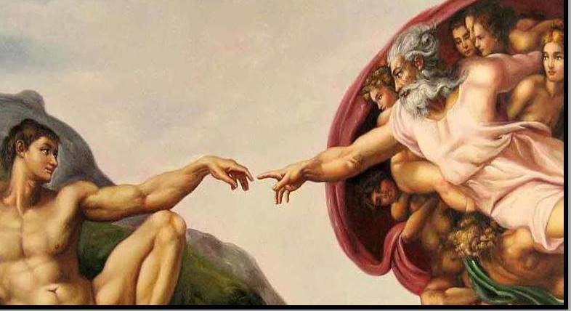
FBC Family Bible Class
Winter – 2019
8:30 AM

Class Subject: Anthropology 501:
The Study of Man.

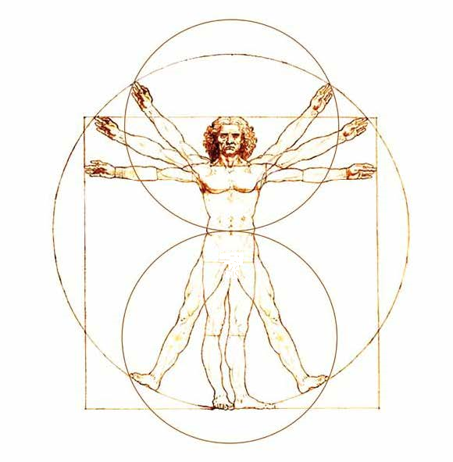
A THEOLOGICAL AND BIBLICAL discussion on the Doctrine of Man. We will discuss the following major themes in what is commonly considered a very pagan and godless academic class in secular Colleges and Universities. We will discuss some views on the origin of man including evolution, the time of man’s origin, the theological significance of man’s origin and the image of God: communicable and incommunicable attributes from God to man, arguments for the trichotomy and dichotomy of man: arguments for and against, the material and immaterial word usage describing man, the heart and mind of man and the human conscience, the controversy of soul and spirit, the old man the flesh and human depravity, the immaterial man and salvation.

Working Lesson Outline:

I. A General Introduction and Overview of the study of Anthropology
II. The Origin of Man: Controversial Views of Creation and Evolution
III. The Time, Theological Significance and Unity of Man’s Origin
IV. The Image of God: Communicable and Incommunicable Attributes
V. The Trichotomy or Dichotomy of Man
VI. The Heart and Mind of Man
VII. The Human Conscience
VIII. The Soul and Spirit of Man
IX. The Old Man and Depravity
X. The Old Man and Regeneration
XI. Review and Introduction to the Doctrine of Hamartiology: The Doctrine of SIN.
I. A General Introduction and Overview of the Study of Anthropology:
1. In reviewing our doctrinal studies match the following theological studies with the correct theological word and put them in chronological order.
Hamartiology Christology 1._____ 100 The Study of How We Got Our Bible
Ecclesiology Pneumatology 2._____ 101 The Study of God the Father
Eschatology Angelology 3._____ 201 The Study of Jesus Christ
Bibliology Demonology 4. _____ 301 The Study of the Holy Spirit
Soteriology 5._____ 401 The Study of Angels and Satan
Theology Proper 6._____ 402 The Study of Demons
Anthropology 7._____ 501 The Study of Man
8._____ 601 The Study of Sin
9._____ 701 The Study of Salvation
10._____ 801 The Study of the Church
11._____ 901 The Study of Future Things
2. Anthropology comes from the Greek term, “anthropos” which means ________________________________.
3. “Even as the strength of a chain is determined by the cohesiveness of each ______________________, likewise, the strength of one’s own theological system lies in the consistence and truthfulness of each doctrine.
4. How are the doctrines of God _________________________ and Man ______________________________ like a cable bridge with two anchor points with one on each side?
5. Where should the starting point be whenever we discuss any theological position? Why?
6. What are the seven most important questions you will ever answer? The life of __________________________.

- Who is ____________________________? My _____________________________________.
- Who is ____________________________? My _____________________________________.
- Why am I__________________________? My _____________________________________.
- What really _______________________? My _____________________________________.
- What should I ______________________? My _____________________________________.
- How should I do ____________________? My _____________________________________.
- When should I do ___________________? My _____________________________________.
7. Why do you think the subject of anthropology has become so controversial on College and University campuses today? What is the primary philosophical and theological premise from secularism?
____________________________________________________________________________________________________________________________________________________________________________________________________
II. The Origin of Man: Controversial Views of Creation and Evolution
1. Why doesn’t Anthropology deal with the subject of the Fall of man? (see page 2)
2. What are the following terms and how do they relate to the subject of Anthropology:
- Naturalism
- Supernaturalism
- Evolution
- Natural Selection:
- Creationism:
- Humanism:
- Secularism:
3. What are some viable objections to the theory of Evolution as being the explanation for the origin of man?
- The theory of evolution is presented as an established fact when in fact all it is is a ______________________.
2. The absence of ______________________________________________________________________________.
3. The Second Law of Thermo-dynamics proves…
4. Scientists have no answers themselves for the origin of life.

5. Irreducible Complexity is the Science of…

4. What are some different views of Creation?
1. Emil Brunner’s View of Creation: The Mythological View.
2. Cortis and Karl Barth’s View of Creation: The Allegorical View.
3. The Literal or Historical View of Creation:
6. How does a high view of the integrity of Revelation, Inspiration and the inerrancy of Scripture and the Sufficiency of Scripture apply to this argument within Creation and the study of Man?

7. What does “FIAT CREATION” mean?- (Ex-Nilo)

8. What is “Deistic Evolution?”

9. What is “Theistic Evolution?”

10. What is Progressive Creationism?

III. The Time, Theological Significance and Unity of Man’s Origin:
1. How is the subject of a Young or Old Earth relevant to our study of Anthropology?
2. What were was the environment and culture that made the views of Charles Darwin so acceptable even to the church of Jesus Christ?

3. How should we then live? In other words, How then do we respond to God, to our fellow man and even to ourselves?
- Man was created and has no ____________________________ existence apart from God.

- Man is the crown jewel of God’s _________________________________.

- There is a brotherhood of mankind.
4.) All of God’s creation bows before the High KING of Heaven.
5.) Man as a creation of God is still a creature and is in fact _______________________________ and finite.
4. How does the idea of all men coming from one single pair: Adam and Eve oppose the core values of modern and humanistic Anthropology?

5. What are the characteristics of a species, in this case mankind?
- Originality:

- Universality:

- Immutability:

6. What is the definition of a species:

7. What are the arguments for the Biblical Creation account for the unity of mankind?
1.) The Historical Argument:

2.) The Physiological and Organic Argument:

3.) The Psychological Argument:

4.) The Argument of Propagation:

5.) The Argument of Philology:

