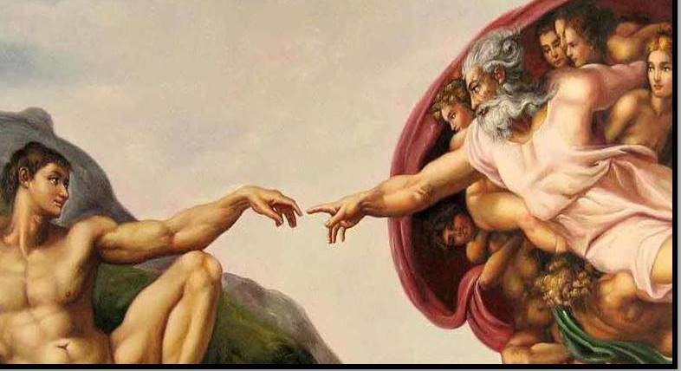
FBC Family Bible Class
March / Spring – 2019
8:30 AM

Class Subject: Anthropology 501:
The Study of Man.

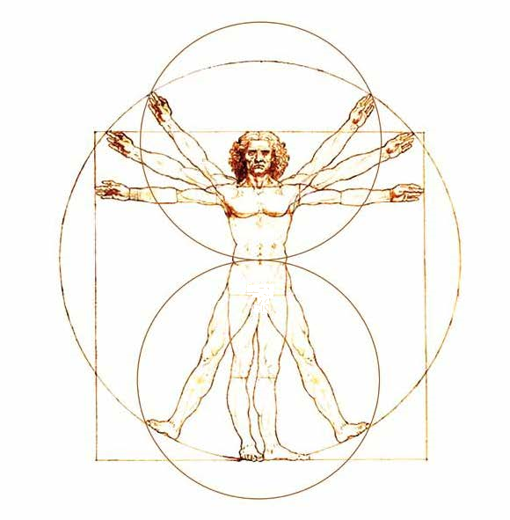
A THEOLOGICAL AND BIBLICAL discussion on the Doctrine of Man. We will discuss the following major themes in what is commonly considered a very pagan and godless academic class in secular Colleges and Universities. We will discuss some views on the origin of man including evolution, the time of man’s origin, the theological significance of man’s origin and the image of God: communicable and incommunicable attributes from God to man, arguments for the trichotomy and dichotomy of man: arguments for and against, the material and immaterial word usage describing man, the heart and mind of man and the human conscience, the controversy of soul and spirit, the old man the flesh and human depravity, the immaterial man and salvation.

Working Lesson Outline: LESSON FIVE

I. A General Introduction and Overview of the study of Anthropology
II. The Origin of Man: Controversial Views of Creation and Evolution
III. The Time, Theological Significance and Unity of Man’s Origin
IV. The Universality of Humanity
V. The Image of God: Communicable and Incommunicable Attributes
VI. The Trichotomy or Dichotomy of Man
VII. The Heart and Mind of Man
VIII. The Human Conscience
IX. The Soul and Spirit of Man
X. The Old Man and Depravity
XI. The Old Man and Regeneration
XII. Review and Introduction to the Doctrine of Hamartiology: The Doctrine of SIN.
VI. The Trichotomy or Dichotomy of Man
1. What are some theories for man’s immaterial nature?
- The Trichotomy of Man:
- The Dichotomy of Man:
2. What are some definitions and explanations for the Body of Man?
- Basor, Soma: Body – (Matthew 6:22; I Corinthians 15:44; Romans 6:12; I Corinthians 9:24)

- Sarx – Flesh:

- Body of Sin: (Romans 6:6)

- Body of Death: (Romans 7:24)

- Body of Humiliation: (Philippians 3:21)

- Earthen Vessel: (II Corinthians 4:7)

- Natural Body: (I Corinthians 15:44)

- Spiritual Bodies: (I Corinthians 15:44)
3. What are some definitions for the Soul of Man?
- Nephesh, Psuche: SOUL -

- Ruach, Pnuema: SPIRIT -

- Lebh, Kardia: HEART -

- Nous, Phronema, Phronesis: MIND -

- Rachamin, Splangchna: Affections / BOWELS –

- Ratson, Noule, Thalema: WILL –

- Suneidesis: CONSCIENCE -

4. What are some Biblical phrases relating to the whole person?
- The Natural Man: (Anthropos psuchokos) –

- The Spiritual Man: (Anthropos pnuematikos) –
- The Carnal Man: (Anthropos sarkikos) –

- The Old Man: (Anthropos palaios) –

5. Is there a state of carnality that a true believer can fall into?
1.) Scriptural References to Carnality to Examine:
- Romans 6:
- Galatians 6:7-10
- I John 2:15
- I John 3:9
- I Timothy 4:7
2.) Some Principles to Consider:
- We are not to ________________ to Scripture or take away from it.

- The Biblical word for “Carnal” (Sarkikos) from (Sarx: pertaining to the flesh) – Fleshly ones, Acting as if you’ve never been regenerated.

- Who were the letters of I and II Corinthians written to? How is this relevant to our discussion?

- What is the context of the need for these two letters from the Apostle Paul?

- See I Corinthians 3:1-15. Consider to whom the context of this passage was written in 3:1?

- Read Galatians 6:7-10 again.

- Read I John 2:15; 3:6,9

- What’s the difference between a “Carnal Christian” and someone who is just religious?

- What significance should II Corinthians 5:17 be to a true born-again believer?

- What does James mean in James 1:25?
VI. The Trichotomy or Dichotomy of Man:
1. What happens to the soul of man when he dies? What’s the difference between the body and soul of man? Why is this important to know? (See Genesis 3:19; Ecclesiastes 12:7; Matthew 6:25, 10:28)
2. Why is the body of man often referred to as a tent or tabernacle? (See 2 Corinthians 5:1; Philippians 1:23,24)
3. What is the “Trichotomy Theory” of Man?
4. What is the Law of Firsts for the words: Body, Soul and Spirit?
- BODY: Genesis 15:4; 25:23; 35:11

- SOUL: Genesis 1:7 Strong’s: H5315 – (nepes):

- Soul, Self, Life, Creature, Person, Appetite, Mind, Living Being, Desire, Emotion, Passion. (a) That which breathes, the breathing substance or being, soul, the inner being of man. (b) Living Being, (c) Living Being (with life in the blood), (d) the man himself, self, person or individual, € seat of the appetites, (f) seat of emotions and passions, (g) activity of mind, (h) activity of will, (i) activity of character.

- SPIRIT: Genesis 1:2; 6:3; 7:22

- I Thessalonians 5:23

- Hebrews 4:12,13

- I Corinthians 2:14,15

- I Corinthians 15:44

- Philippians 1:27

5. What are some objections to the Trichotomist Viewpoint?
- Hebrew: Ruach; Greek: Psuche -

- Hebrew: Nephesh; Greek: Pnuema –

- Ecclesiastes 3:21

- The following words are used by trichotomists to imply different substances, but note the following:

1.) Spirit as well as Soul is used of _____________________________.

2.) Soul is ascribed to _____________________________.

3.) The disembodied dead are called _________________________________.

4.) To lose your ________________________ is to lose it all.

6. What then is the Dichotomist View of Man? What do we hold to and why?
7. What are some Biblical phrases relating to the whole person of Man?
- The Natural Man: (Anthropos – psuchokos) – The ________________________ man. (I Corinthians 2:14)

- The Spiritual Man: (Anthropus – pnuematikos) – The Saved and Spiritual Man. Submitting his will to God’s will and his spirit to God’s spirit. Controlled by the Spirit of God. An ________________________ Christian. (I Corinthians 2:15,16)

- The Carnal Man: (Anthropos – sarkikos) – The Carnal, fleshly person who refuses to submit himself / herself in their entirety to the Lordship of Jesus Christ. Controlled by his ____________________________. A disobedient Christian. (I Corinthians 2:1-4)

8. How does the idea of a Carnal Christian square with the following Scriptures such as:
- Romans 6:

- Galatians 6:7-10

- I John 2:15

- I John 3:9

- I Timothy 4:7
9. What’s the difference between a carnal Christian and someone who’s just religious?

10. What are some terms for the human BODY that describes its various Scriptural uses and terms?
- BODY: (Hebrew: Basor) – Genesis 2: 21, 23, 34; Ezra 10:12; Isaiah 10:18

- FLESH: (Greek: Sarx) –
(a.) The tissue that covers the body: (I Corinthians 15:39; 2 Corinthians 12:7; Colossians 1:22)

(b.) Synonymous use with Body / Flesh: (Colossians 2:5; 2 Corinthians 4:10; I Corinthians 6:16; Ephesians 2:15; 5:28-31; Galatians 4:13)

(c.) The flesh as the origin of man: (Romans 9:3; 1:3; I Corinthians 10:18)

(d.) The flesh can be used in an ethical sense, focusing on the depraved nature of unregenerate man, used for the carnal believer as well. (Romans 8:8, 9; 7:18; Galatians 5:17; 2 Corinthians 1:12; Colossians 2:18)
11.) What are some explanations for the flesh (sarkos) of man?
- The Flesh as the Body of ____________________: (Romans 6:6)

- The Flesh as the Body of ____________________: (Romans 7:24)

- The Flesh as the Body of ____________________________________: (Philippians 3:21)

- The Flesh as an ____________________ _____________________: (2 Corinthians 4:7; 2 Timothy 2:20, 21)

- The Flesh as a _____________________ _____________________: (I Corinthians 15:44a)

- The Flesh as a _____________________ _____________________: (I Corinthians 15:44b)
8. What are some terms to describe the SOUL of Man?
(a.) Descriptive of Man’s seat of _______________________ whether material or spiritual. (Psalm 107:9; Proverbs 25:25; Deuteronomy 12:15, 20; 14:26)
(b.) Descriptive of the focal point of man’s ________________________. (Leviticus 26:11; 2 Samuel 17:8)
(c.) Descriptive of the total person. (Genesis 49:6; Romans 30: 3, 5; Genesis 12:5; Romans 2:9; 13:1)
(d.) Descriptive of life. (Romans 11:3; Philippians 2:30)
(e.) Descriptive of an animate ____________________________ as contrasted to an inanimate stone.
9. What are some terms that describe the SPIRIT within Man?
(a.) Descriptive of the life-energizing force within man. (James 2:26; Luke 8:54, 55)
(b.) Descriptive of Man’s Immaterial Nature. (Genesis 41:8; Daniel 2:1, 3; Matthew 26:41)
(c.) Descriptive of the ___________________ of man. (Romans 11:8; 2 Corinthians 12:18; Philippians 1:24)
(d.) Descriptive at times of man’s ___________________________. (Mark 2:8; I Corinthians 2:11)
(e.) Descriptive of the part of man that speaks of establishing or rejecting a relationship with God. (Psalm 51:10; 2 Corinthians 4:16; Romans 8:16; I Corinthians 14:14, 15; Psalm 78:8)
VII. The Heart and Mind of Man

1. What about the Human Heart of Man? (kardia) is used over 600 times in the Old Testament and over 120 times in the New Testament. God looks on the heart of man (Mark 12:30)
- The heart is the seat of the entire inner man. (Exodus 28:29; I Samuel 25:37; 2 Samuel 18:14; 2 Kings 9:24)

- The heart is the seat of thought and reflection.

  - The heart as related to thinking. (I Corinthians 14:25; Hebrews 4:12; 8:10)

  - The heart as related to perception. (Matthew 13:14,15; Luke 1:66; 2:51; Hebrews 10:16)

- The heart is the seat of emotions.

- ANGER: (Matthew 15:19; James 3:14)

- FEAR: (John 14:27; 16:16)

- EXCITEMENT: (John 16:22; Acts 2:46)

- REMORSE: (Romans 9:2; Acts 21:13)

- SEX / LUST / DESIRE: (Matthew 5:28; 15:19; Ephesians 5:25)

- The heart is the seat of moral consciousness. (Romans 2:15; 5:5; Ephesians 3:16; 2 Corinthians 1:22; Colossians 3:15; Hebrews 10:22)

- The heart is the seat of our volition / WILL. (Romans 6:17; 2 Corinthians 9:7; Hebrews 3:8)
2. How is the word, heart (kardia) used throughout the Scriptures?
(a.) Used to refer to the inner life of man contrasted with his outward life. (Romans 2:29; 2 Thessalonians 2:17; 2 Corinthians 2:12)
(b.) Used to describe the seat of ______________________ both good and bad. (Romans 1:24; 10:1; 2 Corinthians 2:4)
(c.) Used of a man’s intellectual activities, specifically towards his _________________________ and purposes. (Proverbs 16:9; Romans 1:21; Ephesians 1:18; Genesis 6:5; Matthew 5:19,20)
(d.) Used for the focal point of the _____________________ of man. (Romans 2:5; 6:17)
(e.) Used as a source of _________________________ experiences. (2 Corinthians 1:22; 4:; Romans 5:5; Ephesians 3:17; Colossians 3:15)
(f.) Used as the ________________________ device within man of both good and evil. (Romans 1:21; 2:14)
(g.) Used of the source of a person’s self-awareness in a ________________________ sense.
(h.) Used of the physical _________________________, blood pump in the chest of man. (only in the O.T.)
2. How is the word, the MIND or affections of man used in Scripture?
- Nous: (Luke 24:45; 2 Thessalonians 2:13; Romans 12:2; Ephesians 4:23)

- Phronema / phronesis: Designates the non-material part of man as a deep, reflective, meditative thinker.

- Rachamin / Splangchna: The bowels as the seat of emotions and affections. (Colossians 3:12; Philemon 7, 12, 20; Philippians 1:8; 2:1; 2 Corinthians 6:12; 7:15; Genesis 43:30)

VIII. The Human Conscience:

1. How is the word for the WILL or CONSCIENCE of man used in the Scriptures?
- Ratson, Noule, Thalema: Man’s immaterial part that allows for choice and ability to make decisions: (Daniel 8:4; Luke 24:51; Hebrews 2:4)

- Suneidesis: The Human Conscience: Man’s immaterial part that allows man to make ethical choices and decisions based on his or her conscience. (I Corinthians 8:1-13; 10:23-11:1; 2 Corinthians 5:11; I Timothy 4:2; Romans 9:1)
2. How does the conscience work alongside the human heart?
- The conscience works in light of knowledge. (2 Corinthians 4:2)

- The conscience enlightens the heart to motivation. (Hebrews 9:14; 13:18; I Peter 2:19; Romans 9:1; I Peter 2:19)

- The conscience is developed by righteous living. (Acts 24:16)

- The conscience is weakened by suppression and neglect. (I Timothy 4:2; Titus 1:15)

