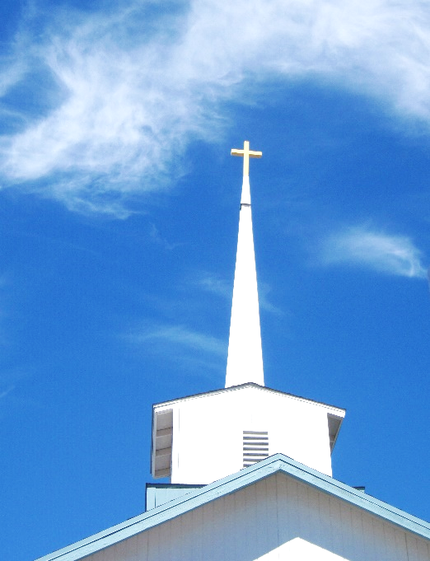
FBC Family Bible Hour
Winter – 2019 8:30 AM

Class Subject: Ecclesiology 801 - The Church.

This theological study on the Doctrine 0f the Church is called the Doctrine of Ecclesiology, coming from the Greek word, “ecclesia” meaning a gathering or an assembly of like-minded believers. As our society becomes more secularized the church must become more sanctified. Our nation and communities, our families and our society are only as strong and morally pure as the church. There is no more essential study than how we as a church must function and remain faithful until Christ returns to this earth. The one institution that God has ordained, next to the family is the Church. Marriage and the family are under relentless attack today by secular humanists and those bent on a one world government. Jesus said, ‘He would build His Church and that the gates of hell would not prevail against it.’

What is the Doctrine of the Church?

1. List on the White Board the current pitfalls, egregious sins and contemporary mistakes of the current church in America but also around the world.

2. On the timeline within the Church Age, where do you think the Church went wrong?

3. When was the word, “Church” first used? (Matthew 16:18)

4. What is the meaning of the Greek word for Church: “koinonia?”

How did the first century Church begin?

5. Some Observations of How the Church came into Existence:

- The Church came by divine _________________________________.

- The Church was initiated by ________________________________.

- The Church when introduced was a _______________________ promised event.

- The Church belongs to ____________________________.

- The Church consists of ____________________________________.

- The Church as a ___________________. (Matthew 16:18,19)

6. Three Bridges to the New Testament Church:

- The ______________________________ Bridge.
- The ______________________________ Bridge.
- The ______________________________ Bridge.
What are the Definitions and Biblical Metaphors for the Church?
- The ______________________ of Christ = The Unity of the Church. (Ephesians 4:15; 5:23; Colossians 1:18, 24; 2:19; Romans 12:5; I Corinthians 12:12-31)

- The ______________________. = The Indwelling Presence of Christ. (I Corinthians 3:16; 2 Corinthians 5:1; Ephesians 2:21; I Cor. 14:12; Ephesians 4:12,16; I Peter 2:5; Eph. 2:21; I Cor. 6:19,20)

- The ______________________. = Our Intimacy with Christ. (Revelation 21:9; 2 Cor. 11:2; Eph. 5:23-32)

- The ______________________. = The Provision and Protection of Christ. (John 10:16; I Peter 2:3, 5:4; John 21:16; Hebrews 13:17; I Cor. 9:1)

- The ______________________. = Our Union with Christ. (John 15:1-7; I Cor. 3:6-9)
- The ______________________. = Our Identity in Christ. (Eph. 2:14-19; I Tim. 3:4,5,12)
- The ______________________. = Our Service to and for Christ. (I Tim. 2:5; I Peter 2:9)
Theological Definitions of the Church:
- A Church is an assembly of professing ______________________.
- A Church has the unique presence of _______________________.
- A Church is under the ___________________________ of the Word of God.
- A Church is equipped by the Holy Spirit to carry out the __________________________.
- A Church administers the ____________________________ as commanded in Scripture.
- A Church reflects the spiritual ____________________ given by the Holy Spirit.

The Birth of the Church: The Apostolic Church Age - (30-100)
7. The First Period in the Apostolic Church Age was the ____________________________ Church. (30 – 35 AD)

- The First Church’s Great Beginning on the Day of Pentecost in (Acts 2) (30 AD)

- The First Church’s Locality: Jerusalem. (Acts 1:8)

- The First Church’s First Members: (Acts 6:1; 2:9-11; 6:9; 6:5)

- The First Church’s Leader: ___________________________ (Acts 1: - 6:)

- The First Church’s Doctrines:

____________________________________________________________________________________
________________________________________________________________________________________________________________________________________________________________________
- The First Church Spirit: (Acts 2:44, 45; 4:32-37)

____________________________________________________________________________________________________________________________________________________________________________________________________________________________________________________________
8. The Second Period in the Apostolic Church Age was the ______________________________ Church. (35 – 48 AD)

- The Great Preaching of Stephen: (Acts 6:1-14; 7:2-53)

- The Persecution of Saul. (Acts 7:58; 22:3; 8:3; 26:9-11; 11:19,20; 8:4)

- Philip in Samaria. (Acts 6:5; 8:5-17; 8:40)

- Peter at Joppa and Caesarea. (Acts 9:32-43; 10:9-16; 17-48)

- Saul’s Conversion to Paul. (Acts 9:1-22)

- The Church at Antioch. (Acts 11:19-29; 9:26,27; 11:25,26; 26:28; I Peter 4:16)

- The First Missionary Journey. (Acts 13:2,13; 13:5,9)

- Revisiting the Churches. (Acts 14:23)
- The Council at Jerusalem. (Acts 15:)

9. The Third Period in the Apostolic Church Age was the _______________________________ Church. (48 – 68 AD)

- Paul’s Second Missionary Journey. (Acts 15:36-18:22)

- Paul’s Third Missionary Journey. (Acts 18:23-21:17)

- Paul’s Fourth Missionary Journey. (Acts 27: 28:)

- First Imperial Persecution. (65-68 AD)

- Martyrdom of St. Paul. (68 AD)

10. The Fourth Period in the Apostolic Church Age was the ______________________________ Church. (68 – 100 AD)

- The Fall of Jerusalem. (70 AD) Matthew 24:

- The Second Imperial Persecution. (90-96 AD) Revelation 1:9
- The Compilation of the New Testament.
- The Spiritual and Doctrinal Condition of the Church. (Acts 20:29,30; Colossians 2:18,19; I John 2:18,19)
- The Government of the Church. (Acts 20:17,28; I Timothy 3:8-13; Romans 16:1)
The Infancy of the Church: The Persecuted Church Age - (100-313)
11. Part One: The Imperial Persecutions
12. Part Two: The Formation of the New Testament Canon / Growth of Ecclesiastical Organizations

The Childhood of the Church: The Imperial Church Age – (313-590)
13. Part One: The Victory of Christianity

14. Part Two: The Founding of Constantinople / Division of the Empire / Suppression of Heathenism / Controversies and Church Councils.

15. Part Three: Growth and Power of the Roman Catholic Church / Downfall of the Roman Empire

