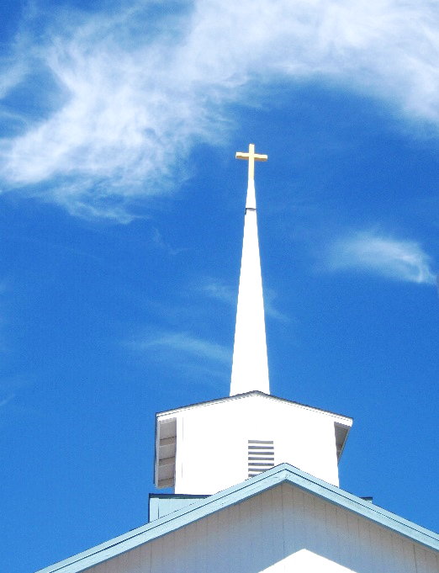
FBC Family Bible Hour
Winter – 2019 8:30 AM

Class Subject: Ecclesiology 801 - The Church.

This theological study on the Doctrine 0f the Church is called the Doctrine of Ecclesiology, coming from the Greek word, “ecclesia” meaning a gathering or an assembly of like-minded believers. As our society becomes more secularized the church must become more sanctified. Our nation and communities, our families and our society are only as strong and morally pure as the church. There is no more essential study than how we as a church must function and remain faithful until Christ returns to this earth. The one institution that God has ordained, next to the family is the Church. Marriage and the family are under relentless attack today by secular humanists and those bent on a one world government. Jesus said, ‘He would build His Church and that the gates of hell would not prevail against it.’

When Does a “Church” Cease Being the True Church?

When it stops functioning as the True Church:

- The gathering of individuals ignores its mission in _________________________.
- The gathering no longer ______________________, love and ____________________ to its members.
- The gathering no longer administrates church _________________________.
- The gathering no longer teaches sound ________________________.
- The gathering no longer has common ground for Christian ________________________.
- The gathering no longer ______________________ or serves the Lord’s _______________________.
- The gathering becomes _______________________.
- The gathering is _________________ with many ______________________.
What does the Universal Church mean?

- I Corinthians 12:12-27 –

What are Jurisdictions and how are they relevant to the Church?

- The ____________________________. Genesis 1: 2:
- The ____________________________. Genesis 1: 2:
- The ____________________________. Deuteronomy 6:
- The ____________________________. Genesis
- The ____________________________. Acts 2:
What are the Four Forms of Church Government?

- The ____________________________ Church Government.
- The ____________________________ Church Government.
- The ____________________________ Church Government.
- Family Bible Church’s Form of Church Government:
_________________________________________________________

_________________________________________________________

_________________________________________________________

_________________________________________________________

What are the Biblical Requirements for an Elder and Pastor?
- What are the seven titles for the man of God who leads the Church?

1.) ____________________________. 2.) ______________________________.

3.) ____________________________. 4.) ______________________________.

5.) ____________________________. 6.) ______________________________.

7.) ____________________________.

1. The Elder: (I Timothy 3:1-7; Titus 1:5-9) NKJV

- A bishop must be _________________________________________________________________
- The husband of one wife. __________________________________________________________
- Temperate _______________________________________________________________________
- Sober-minded ____________________________________________________________________
- Of Good behavior _________________________________________________________________
- Hospitable _______________________________________________________________________
- Able to teach ______________________________________________________________________
- Not given to wine ___________________________________________________________________
- Not violent ________________________________________________________________________
- Not greedy for money _______________________________________________________________
- Gentle ____________________________________________________________________________
- Not quarrelsome ____________________________________________________________________
- Not covetous _______________________________________________________________________
- One who rules his own house well – having his children in submission with reverence ___________
- Not a novice ________________________________________________________________________
- Must have a good testimony inside and outside the church __________________________________
2. The Pastor:

- A man of Spiritual ____________________________. (Prebusteri)
- A man who __________________________________. (Episcopos)
- A man who __________________________________ the flock of God. (Poimen)
- A man who __________________________________ the Word. (Keroso)
- A man who __________________________________ the Word. (Didasko)
- A man who __________________________________. (Doulos)
- A man who bears the __________________________ of God to others. (Aggelo)
3. The Deacon or a Deaconness: (See I Timothy 3:8-13)
- Reverent __________________________________________________________________________
- Not double-tongues _________________________________________________________________
- Not given to much wine ______________________________________________________________
- Not greedy for money ________________________________________________________________
- Holding the mystery of the faith with a pure conscience ____________________________________
- Proven ____________________________________________________________________________
- Being found blameless _______________________________________________________________
- Likewise, their wives must be reverent __________________________________________________
- Not slanderers ______________________________________________________________________
- Temperate _________________________________________________________________________
- Faithful in all things ___________________________________________________________________
- Husbands of one wife __________________________________________________________________
- Ruling their children and their own houses well _____________________________________________
3. The Evangelist:
- Acts 21:8 –
- Matthew 28:18-20 –
- Acts 1:8 –
- Mark 16:15 –
- Ephesians 4:11 –
What About the Members of the Body? What Should the Core Values of the Local Church membership be?
FBC Covenant Agreement
By God’s grace and for His glory I will say, "Yes" to God and give
myself away by doing the following as unto the Lord...
______________= A spirit of Holiness: I will faithfully maintain a daily lifestyle of personal prayer and devotional reading of the Word of God being careful to maintain a vibrant personal intimacy with God and holiness before God. Psalm 119:97-105; I Thessalonians 5:17
______________ = A spirit of Faithfulness: I will faithfully be in weekly fellowship, as much as is possible, with other believers not forsaking the assembly of myself as is the manner of some. Heb. 10:28, 29
______________ = A spirit of Humility: I will model Biblical maturity and humility by preferring others as better than myself. Philippians 2:1-4
______________ = A spirit of Sacrifice: I will make myself available for whatever ministry God calls me into knowing that my life is not my own that I have been bought with a price. I will maintain communication between the church staff and other ministries in order to eradicate the potential for anger, bitterness or misunderstanding between believers. Psalm 133: Ephesians 4:1-3
______________ = A spirit of Freedom and Liberty: I will seek to free others by giving them permission to fail and offering them the liberty to succeed. I will be willing to let go of control in order that others might be freed to achieve God’s best in His way in His time by His means.
________________= A spirit of Truth: I will seek to speak the truth in love knowing that both are needed and necessary non-negotiables in fostering healthy loving relationships and confrontations. I understand that it is within my fallen nature to withhold the truth in love or to speak the truth without love, I know I need to do both under the instruction of the Word of God and the empowerment of the Holy Spirit. I realize God hates lies and liars and that prior to becoming a believer I was born dead in my trespasses and sins and was a child of my father the Devil who is a liar and the father of lies. Jesus said of Himself that He was the truth and that the truth would set us free. I will therefore seek to speak the truth lovingly, respectfully, thoughtfully and courageously as God leads me to do so with His Word, in His time, by His grace. The Bible tells us that faithful are the wounds of a true friend. I will seek to be a true friend by taking every opportunity God gives to me to sew truth into every relationship as a minister of reconciliation using the Word of reconciliation. Ephesians 4:15, 29-32; John 8:32, 44; John 14:6; Proverbs 27:6; II Corinthians 5:18-21
______________ = A spirit of Submission: I will seek opportunities to take the initiative in using the word of reconciliation as a minister of reconciliation. II Corinthians 5:17-21 I will seek to keep short accounts with God and with others not allowing the enemy to use me as a wedge between other believers. I will not permit in my own life or others that speak to me a spirit of gossip or the sowing of discord among the brethren. Proverbs 6:17-19
I will maintain loyalty and confidentiality with what I come to know and understand about individual members of the body and the concerns of the church as a whole. If someone comes to me with a criticism regarding a fellow believer, I will encourage them to biblically deal with their concerns according to Matthew 18:15-20 and even go with them in order that communication and reconciliation is assured. II Cor. 5:17-21
______________ = A spirit of Discipleship: I will weekly hold myself accountable for discipling times with a Paul in my life. Proverbs 18:1 I will weekly seek discipling times with a Timothy in my life. I will seek to help fulfill the great commission by developing a multiplicating, discipling ministry to the fourth generation and beyond. Matthew 28:18-20; Acts 1:8; II Timothy 2:2
______________ = A spirit of Servant – Hood: I will seek opportunities to share my faith as a lifestyle with the unbelieving world knowing that through my obedience others might follow my example. Acts 4:31; I Corinthians 4:16; 11:1; Phil.3:17
______________ = A spirit of Excellence: I will do my work as unto the Lord knowing that to Him I will have to give an account one day. Matthew 5:37; I Corinthians 3:5-17; II Corinthians 1:19, 20. I will willingly submit my work to the careful examination of those over me in order that I might become a better servant in God’s vineyard. Hebrews 13:17
______________ = A spirit of Courage: I will display a spirit of godly courage in my life by living in an attitude of victory. Whenever I need to do what is right regardless of inconvenience or hesitancy on my part I will seek to walk in courage displaying victory over my fears. Romans 8: 28-39
______________ = A spirit of Grace: I will ask God to continually place a watch over my mouth that when I speak my speech will be seasoned with salt. I will lift up and encourage others as a spiritual cheerleader with my speech and conduct to lift up and edify the individual as well as the entire body of Christ so that the beauty of Christ and His bride will be seen by all who gaze on her. Psalm 141:3; Ephesians 4:29; II Timothy 2:1; II Peter 1:3-8; 3:18
What are the Two Ordinances of the Local Church?
1. Baptism:
2. The Lord’s Supper:

