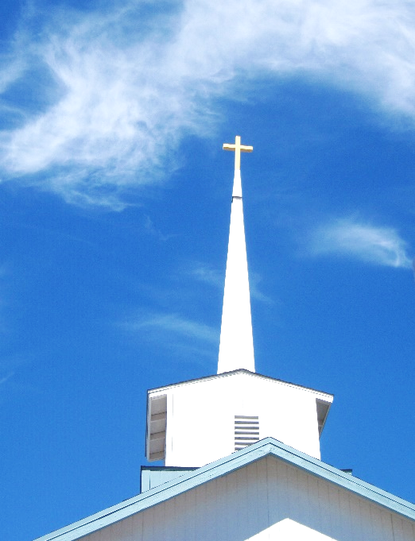
FBC Family Bible Hour
Winter – 2019 / 2020 8:30 AM

Class Subject: Ecclesiology 801 - The Church.

This theological study on the Doctrine 0f the Church is called the Doctrine of Ecclesiology, coming from the Greek word, “ecclesia” meaning a gathering or an assembly of like-minded believers. As our society becomes more secularized the church must become more sanctified. Our nation and communities, our families and our society are only as strong and morally pure as the church. There is no more essential study than how we as a church must function and remain faithful until Christ returns to this earth. The one institution that God has ordained, next to the family is the Church. Marriage and the family are under relentless attack today by secular humanists and those bent on a one world government. Jesus said, ‘He would build His Church and that the gates of hell would not prevail against it.’

LESSON FIVE: PART ONE of TWO-
Agree or Disagree? The subject and teaching of Spiritual Gifts is adequately being taught in the Christian church today.

Who is the Holy Spirit and how does a believer get filled with the Holy Spirit?

- Who is the ________________ _________________?

- What does the Holy Spirit _____________?

John 16:1-5

John 16:6,7

John 16:8-11

John 16:12

John 16:13

John 16:14,15

John 16:23,24

- What is the ____________________ of the Holy Spirit and how is it different (or is it) from the filling of the Holy Spirit?

John 3:30-36

John 7:37-39
Romans 8:9-11

Romans 12:13

I Corinthians 12:13

Ephesians 5:18

Colossians 2:8-10

- Why are so few Christians ___________________ with the Holy Spirit?

Psalm 66:18

Proverbs 3:5,6

Proverbs 16:18

Proverbs 29:25

Galatians 5:16,17

Galatians 5:19-26

I John 2:15-17

- How can a believer be ______________________ with the Holy Spirit?
John 3:30
Romans 12:1,2
Ephesians 4:30-32
Ephesians 5:18
I Thessalonians 5:19
- Where does ____________________ come to play in being filled with the Holy Spirit?
Romans 10:17
What is the difference between an organization and an organism?

How does the Organization (East) and the Organism (West) come together?
Principles in Unwrapping Your Spiritual Gift(s):

- Spiritual Gifts are given to every ____________________________:

Romans 12:5,6

I Corinthians 12: 13: 14:

Ephesians 4:7,8

I Peter 4:10

- Spiritual Gifts are given ____________________________:

I Corinthians 12:11,18,24,28

- Spiritual Gifts are __________ for self-edification only but for the edification of the Church: I Corinthians 12:

- Spiritual Gifts must be ________________________ individually and used for God’s glory.

I Timothy 4:14

How to Discover Your Spiritual Gift(s):

- _______________________ About It:

Ask. Seek. Knock – Matthew 7:7

James 1:5

- Finding your spiritual gift(s) are similar to knowing your _________________________ giftings. How did you come to know what you are good at?

- It is better to _____________ know the name of your spiritual gift(s) and be using them; than to know the name of your spiritual gift(s) and not be using them.

Philippians 4:6,7

Ephesians 2:10

- When using your spiritual gift(s) make sure they are being used for the _______________________ of the Body of Christ.

- Don’t ______________ or be jealous of others who have a gift or gifts you don’t have. Be faithful using yours. Rejoice in others that are using their gifts.

- ___________________ to understand what your gift(s) are and how best to grow into spiritual maturity using them.

II Timothy 2:15

- Be sure you are continually being ___________________ with the Spirit and not using your gift(s) in the energy of the flesh.

James 4:17

Jeremiah 17:9

Psalm 66:18

- Use your spiritual gift(s) before you lose them. A moving vehicle is easier to steer.

- Don’t _____________________ your spiritual gift(s) with others who have the same gift(s). There should be freedom in using your gift(s) as God gave them to you. Your unique life experiences, personality, training, environment, etc.

- Where has God been _________________ you? How has He shown you His pleasure and blessing through your life and ministries?

What is the Biblical Process of God’s Gift(s) and Giftings?

- I Corinthians 12:1 – “Now concerning spiritual gifts, brethren, I do not want you to be _____________________ (Strong’s 50).” What, was Paul’s __________________ for the church in Corinth? What was the Corinthian problem that warranted two letters from the Apostle Paul?

(50) –

- I Corinthians 12:2 – What were the ___________________ before they were born again?

- I Corinthians 12:3 – What was it that ____________________ the true believers in the Church of Corinth after they were born again?

- I Corinthians 12:4 – “Now there are ___________________ (1243) of ______________, (5486) but the same Spirit…”

(1243) –

(5486) –
- I Corinthians 12:5 – “There are diversities of _______________________ (1248) but the same Lord…”

(1248) –

- I Corinthians 12:6 – “And there are diversities of _________________________ (1755), but the it is the same God who _________________ (1754) all in all.”

(1755) –

(1754) –

- I Corinthians 12:7 – “But the _________________________ (5321) of the Spirit is given to each one for the profit of all.”

(5321)

What is a Bestowed (DORIA) Gift?

- Definition:

- Ephesians 3:7

- Ephesians 4:7

What is a Free Gift (CHARISMA)?

- Definition:

- Romans 5:17

- Romans 12:6

- It is Given to all _________________________. I Corinthians 12:1-7

- It is given ___________________________. I Corinthians 12:8-11

- It is given to be used in ___________________ within the Body of the Christ. I Corinthians 12:12-26

- It is to be given for the mutual __________________________ of the Body not exclusively for the individual believer. I Corinthians 14:1-5,12,26

What is a Ministry (DIAKONIA)?

- Definition:

- I Corinthians 12:4,5
- Ephesians 4:12
- I Peter 4:10
What is the Effect (ENERGMA)?

- Definition:

- I Corinthians 12:4-6
What is the Manifestation (PHANEROSIS)?

- Definition:

- I Corinthians 12:1
- I Corinthians 12:7
ILLUSTRATION:

__________________________________________________________________________________________
______________________________________________________________________________________________________________________________________________________________________________________________________________________________________________________________________________
What is the Stewardship Principle Here (OIKONOMOS)?

- Definition:

- I Peter 4:10
- Ephesians 3:2
- I Corinthians 12:7

FBC Family Bible Hour
Winter – 2019 / 2020 8:30 AM

Class Subject: Ecclesiology 801 - The Church.

This theological study on the Doctrine 0f the Church is called the Doctrine of Ecclesiology, coming from the Greek word, “ecclesia” meaning a gathering or an assembly of like-minded believers. As our society becomes more secularized the church must become more sanctified. Our nation and communities, our families and our society are only as strong and morally pure as the church. There is no more essential study than how we as a church must function and remain faithful until Christ returns to this earth. The one institution that God has ordained, next to the family is the Church. Marriage and the family are under relentless attack today by secular humanists and those bent on a one world government. Jesus said, ‘He would build His Church and that the gates of hell would not prevail against it.’

LESSON FIVE: PART TWO –

Is there a possibility some Christians have less of the Holy Spirit than others?

- John 3:30

- Colossians 2:8-10

If all believers have all of the Spirit, then do we also potentially have all of the gifts?

What should every believer have paramount in their minds when exercising their spiritual gift(s)?

- I Corinthians 13:

What are the four kinds of Spiritual Gifts as listed in the Scriptures?

- _________________________ Gifts

- _________________________ Gifts

- _________________________ Gifts

- _________________________ Gifts

1. What are the Speaking Gifts?

- The Gift of ________________________________. Ephesians 4:11; 2 Timothy 4:1-5; Acts 21:8

- The Gift of ________________________________. I Corinthians 12:10; 14:1; Romans 12:6
Deuteronomy 18:18-22 The Test of a Prophet.
Ephesians 2:19-22 The Building and Foundation of the Church.
- The Gift of _________________________________. Romans 10:17; 12:7; Hebrews 5:11-6:1

- The Gift of _________________________________. Romans 12:8; I Thessalonians 5:12-14

- The Gift of _________________________________. I Corinthians 12:8; II Timothy 2:15

- The Gift of __________________________________. I Corinthians 12:8

2. What are the Serving Gifts?

- The Gift of ________________________________. I Corinthians 12:4-14, verse 9; Romans 1:16,17; Ephesians 6:16; Hebrews 11:6; I Timothy 6:6-12
- The Gift of ________________________________. I Corinthians 12:10; 14:26-40 (14:29)

- The Gift of _________________________________. Romans 12:7; I Corinthians 12:28; Acts 20:28,35

- The Gift of _________________________________. I Corinthians 12:5; Romans 12:8

- The Gift of _________________________________. I Corinthians 12:5; II Corinthians 8:19,20; 9:6-15

- The Gift of ________________________________. Romans 12:8

- The Gift of _________________________________. Romans 12:8
Matthew 6:1-4
I Corinthians 16:1,2
I Chronicles 29:3-9
II Corinthians 9:6-5
II Corinthians 9:7
Malachi 3:10
Luke 21:1-4
II Corinthians 8:1-5
- The Gift of _________________________________. I Peter 4:9; Romans 12:13; I Timothy 3:2; 5:10

- The Gift of _________________________________. Ephesians 4:1,11,12

- The Gift of __________________________________. II Corinthians 8:19,20; 9:6-15; I Corinthians 12:5;

- The Gift of __________________________________. I Corinthians 12:8

