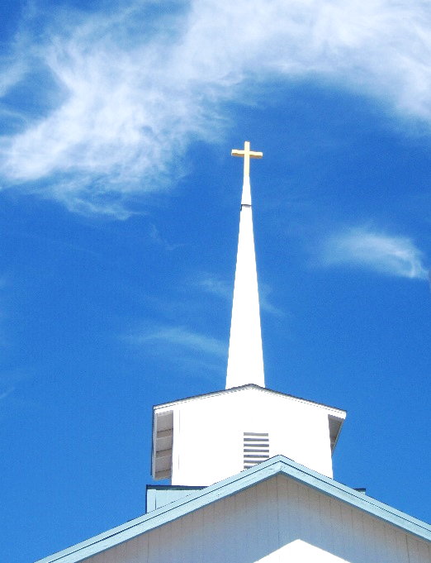
FBC Family Bible Hour
SPRING 2020 / 8:30 AM

Class Subject: Ecclesiology 801 - The Church.

This theological study on the Doctrine 0f the Church is called the Doctrine of Ecclesiology, coming from the Greek word, “ecclesia” meaning a gathering or an assembly of like-minded believers. As our society becomes more secularized the church must become more sanctified. Our nation and communities, our families and our society are only as strong and morally pure as the church. There is no more essential study than how we as a church must function and remain faithful until Christ returns to this earth. The one institution that God has ordained, next to the family is the Church. Marriage and the family are under relentless attack today by secular humanists and those bent on a one world government. Jesus said, ‘He would build His Church and that the gates of hell would not prevail against it.’

LESSON SEVEN: SPIRITUAL GIFTS – Sign Gifts: 4. Healing.
The Four Basic Categories of Gifts:
1. Speaking Gifts: 2. Serving Gifts: 3. Sign Gifts: 4. Temporary Gifts:
Evangelism – Ephesians 4:11 Faith – I Cor. 12:9 Tongues – I Cor. 12:10 Apostles – Acts 1:21,22
Prophecy – I Cor. 12:10 Discernment – I Cor. 12:10 Interpretation of Tongues Miracles / Powers Teaching – Romans 12:7 Helps / Ministering – I Cor. 12: Healing – I Cor. 12:9 28; Romans 12:7
Exhortation – Romans 12:8 Mercy – Romans 12:8
Word of Knowledge – Administration / Leadership –
I Cor. 12:8 I Cor. 12:5
Word of Wisdom – Ruling – Romans 12:8
I Cor. 12:8 Giving – Romans 12:8
Hospitality – I Peter 4:9
Pastor – Teacher – Ephesians 4:1,11

1. REVIEW: What were the “Sign Gifts” to be used for?

- Matthew 12:38,39 –
- Mark 16:15-20 –
- John 6:24-36 –
- John 20:30,31 –
- I Corinthians 1:20-23 –

PERSONAL TESTIMONY WHILE IN THE CHARISMATIC MOVEMENT:

- Bible Study Blind Woman –
- My Mother in Law’s Healing –

2. What is the Biblical Gift of Healing? (See MacArthur’s ‘Charismatic Chaos’, pages 199,200)

3. Does God heal today? Does God use ‘Faith Healers’ as His instruments for divine healing? (See James 5:13-16)

3. How did Jesus heal when He was here on earth?

- Jesus healed with a ___________________ or a _________________________.
(Matthew 8:8; Mark 5:27-29)

- Jesus healed _________________________________. Mark 5:29
- Jesus healed _________________________________. Luke 4:38,39
- Jesus healed _________________________________. Luke 4:40; 9:10,11
- Jesus healed ___________________________ diseases.
- Jesus _________________________ people from the dead. Mark 5:35-42; Luke 7:11-16
4. Does God allow sickness today? WHY?
- Exodus 4:11 –
- Job 2:6 –
- John 9:3 –
- Galatians 4:13-15 –
- Philippians 2:25-30 –
- I Timothy 5:23 –
- 2 Timothy 4:20 –
5. How does God use our sickness for His purposes and glory?
- Some sickness comes from _____________________. (Luke 13:1-11)
- Some sickness is ____________________________ for our sin. (Deuteronomy 28:20-22; I Corinthians 11:)
- Some sickness is given by God to prevent _____________________________. (2 Corinthians 12:7)
- Some sickness ultimately encourages spiritual ____________________________. (James 1:2-4)
- Some sickness is used by God to display His providential _______________________________. (John 9:32,33)
- There is a sickness unto __________________________. Acts 5:
- Our sickness can bring great comfort and ______________________________ to other weaker believers.
6. Why are “Faith Healers” suspect in their giftings today?
- (See MacArthur’s ‘Charismatic Chaos’, pages 201-203)
LESSON EIGHT: SPIRITUAL GIFTS – Temporary Gifts: 1. Apostles. 2. Miracles / Powers.

6. Why do evangelical Christians consider the Gift of Apostleship temporary for the first century?
- Ephesians 2:20 –
7. Why do most conservative evangelical Christians consider miracles and powers as not being authentic manifestations of the Holy Spirit today?

- (See MacArthur’s ‘Charismatic Chaos’, pages 200,201)

