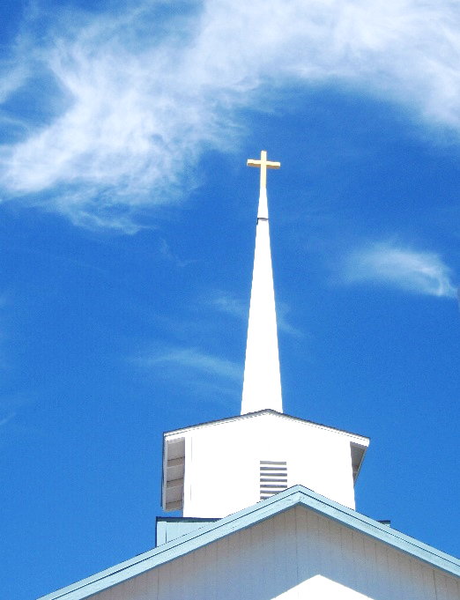
FBC Family Bible Hour
SUMMER 2021 / 8:30 AM

Class Subject: Ecclesiology 801 - The Church.

This theological study on the Doctrine 0f the Church is called the Doctrine of Ecclesiology, coming from the Greek word, “ecclesia” meaning a gathering or an assembly of like-minded believers. As our society becomes more secularized the church must become more sanctified. Our nation and communities, our families and our society are only as strong and morally pure as the church. There is no more essential study than how we as a church must function and remain faithful until Christ returns to this earth. The one institution that God has ordained, next to the family is the Church. Marriage and the family are under relentless attack today by secular humanists and those bent on a one world government. Jesus said, ‘He would build His Church and that the gates of hell would not prevail against it.’

LESSON TWELVE: Church History – (1453-1648) A.D.
The Seven General Periods of Church History:
1. The APOSTOLIC Church 30-100 A.D.
2. The PERSECUTED Church. 100-313 A.D.
3. The IMPERIAL Church. 313-476 A.D.
4. The MEDIEVAL Church. 476-1453 A.D.
5. The ___________________________ Church. 1453-1648 A.D.
6. The ___________________________ Church. 1648-1970 A.D.
7. The ___________________________ Church. 1970-Present
Hymn #275 HOW FIRM A FOUNDATION
5. The REFORMED Church. (1453-1648)
1. Apart from the Sovereign and providential hand of God in His righteous decrees over time, what were the three greatest contributions to the time of the Reformation to pull the world from the Medieval Dark Ages? (H. 117-118)
1.) ___________________________________________________________________________
2.) ___________________________________________________________________________
3.) ___________________________________________________________________________
2. Who is credited as being the father of the Reformation? (H.119)

3. What single greatest decision of the Roman Catholic Church set Martin Luther’s mind on edge?

4. What was nailed to the door of Whittenberg Cathedral on October 31st, 1517? Why is this document so essential in understanding and appreciating the power of the Reformation?

5. As a result of Martin Luther’s convictions what did Pope Leo X do in June of 1520?

6. What is the Diet at Worms on April 17th, 1521?

7. Why is Wartburg Castle and Frederick of Saxony of great importance to the Reformation? (H.120)

8. When did the followers of Martin Luther be called ‘Protestants?’ (H.121)

9. Who are the other leaders of the Reformation and why are they important to remember and understand? (H.122-125)
- ML_____________________________: (1483-1546) (H.131-132)

- UZ_____________________________: (1517,1522)

- JC______________________________: (1509-1564) (H.132)

- JT _____________________________: (1536)

- TC _____________________________: (H.133)

- JK _____________________________: (1505-1572) (H.133,134)

10. What are the (5) Great Principles of the Reformation? (H.125-128)
- Scriptural _________________________.
- Rational __________________________.
- Personal __________________________.
- Spiritual __________________________.
11. What are the Five Solas of the Reformation?
- Sola Scriptura: ___________________________________________
- Sola Fide: ___________________________________________
- Sola Gracie: ___________________________________________
- Sola Christus: ___________________________________________
- Sola Deo Gloria: __________________________________________
12. What was the Counter-Reformation? What did the Roman Catholic Church hope to accomplish? (1545-1563) (H.129)

