WINTER PEACE: What Storms Does God Want to Still in Your Life?
(“ P e a c e B e S t i l l ” – J e s u s)
Selected Scriptures

FBC:AM; 12-19-21; 2021 Seasonal Growth Challenge: WINTER
Bring it Home / Introduction:

1. Thunderstorm: Jesus on the Boat with His Disciples – (Matthew 8:23-27; Mark 4:35-41; Luke 8:22-25)
“Peace, Be Still!” - Jesus

2. Sinkhole: Mary receives the Announcement of the Birth of Christ: The Messiah – (Luke 1:26-38)
“Peace, Be Still!” - Jesus

3. Blizzard: Joseph receives assurance that his Betrothed is Pregnant by the Holy Spirit. – (Matthew 1:18-25)
“Peace, Be Still!” - Jesus

4. Hurricane: Joseph and Mary travel to Bethlehem to Deliver the Christ Child. – (Luke 2:1-7)
“Peace, Be Still!” - Jesus

5. Hailstorm: The Shepherds receive the Announcement from the Angelic Hosts. – (Luke 2:8-20)
“Peace, Be Still!” - Jesus

6. Sandstorm: The Wise Men Come from the East Seeking the King of kings and Lord of lords. – (Matthew 2:1-12)
“Peace, Be Still!” - Jesus

7. Earthquake: Joseph and Mary Flee to Egypt to Escape Herod. – (Matthew 2:13-15)
“Peace, Be Still!” - Jesus

8. Avalanche: Herod Seeks to Kill Children of Two Years Old and Under. – (Matthew 2:16-18)
“Peace, Be Still!” - Jesus

9. Tornado: The Child – Jesus, Returns to Nazareth. – (Matthew 2:19-23)
“Peace, Be Still!” - Jesus

10. Tsunami: Jesus the Man Faces Crucifixion and Death. – (Matthew 26: - 28:)
“Peace, Be Still!” - Jesus

Bring it Home / Moment of Decision:

SPRING SEED
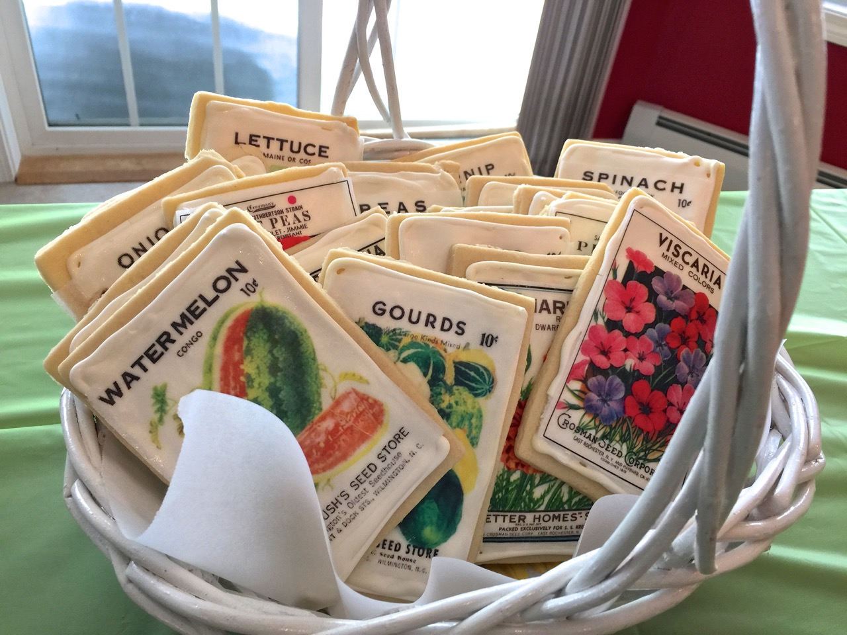
(Saturday, March 20th – Sunday, June 20th 2021)
Sunday, March 21st, 2021
Sermon: “This Spring: What Does God Want to Plant in My Life”
SUMMER FRUIT
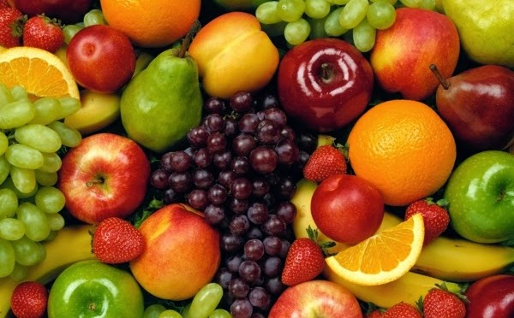
(Sunday, June 21st – Wednesday, September 22nd, 2021)
Sunday, June 20th, 2021
Sermon: “This Summer: What Fruit Does God Want to Grow in My Life?”
FALL VICTORY
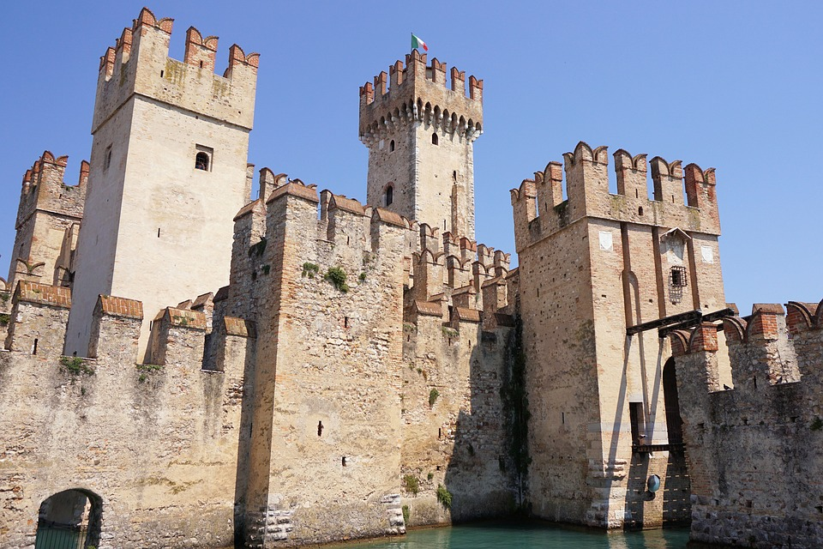
(Wednesday, September 22nd – Tuesday, December 21st,2021)
Sunday, September 19th, 2021
Sermon: “This Fall: What Satanic Fortress Does God Want to Destroy in My Life?
WINTER PEACE
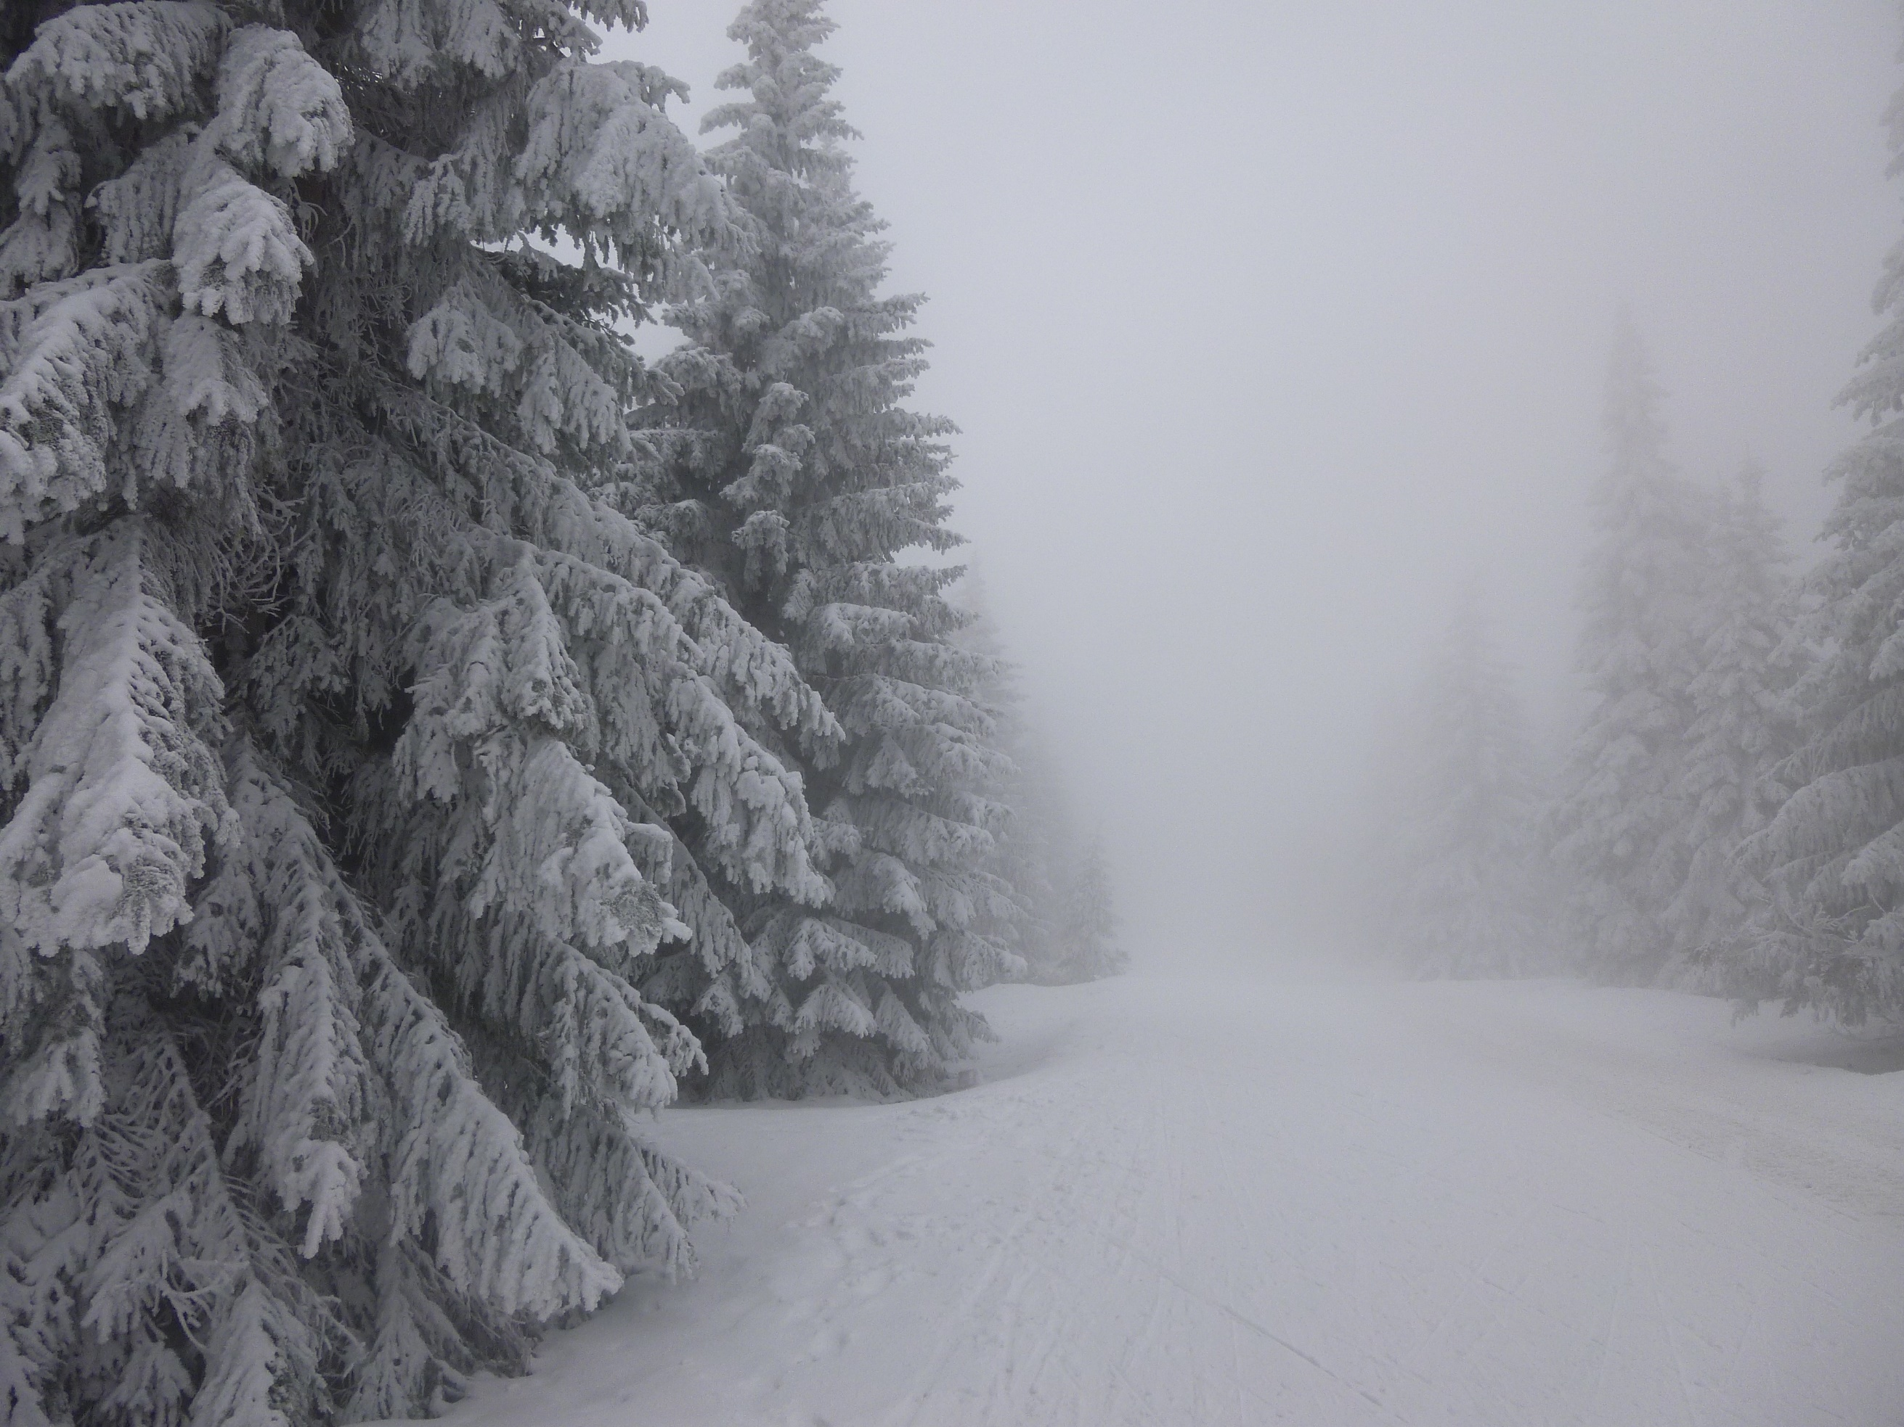
(Tuesday, December 21st – Saturday, March 20th, 2022)
Sunday, December 19th, 2021
Sermon: “This Winter: What Storm Does God Want to Still in My Life?

